FACE DETECTION

import dlib

import cv2 as cv

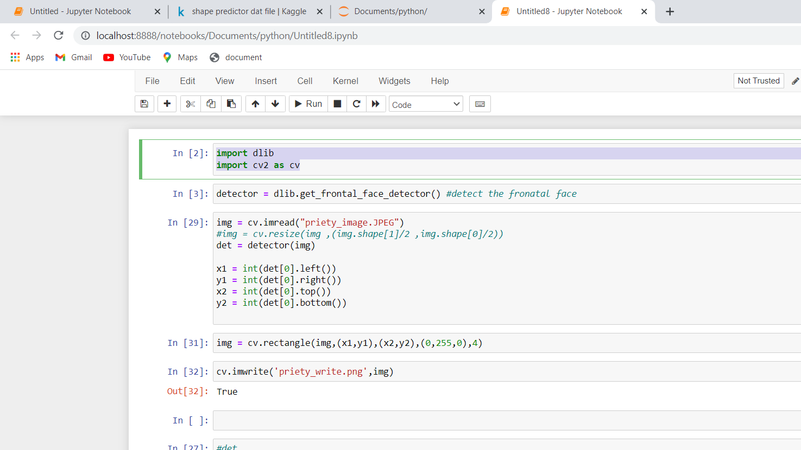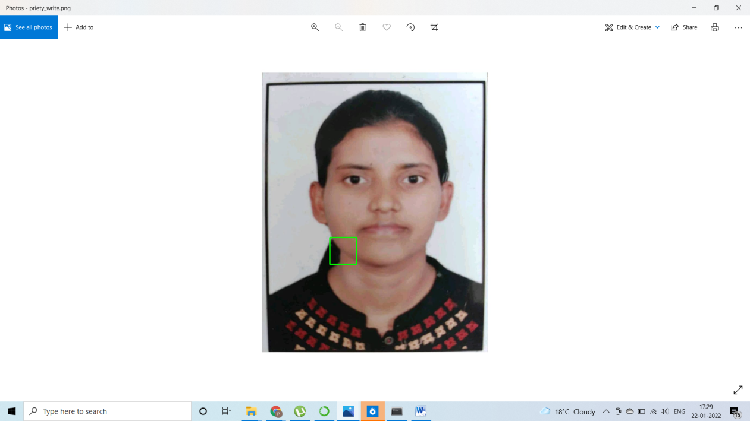

Face not detected correctly it is drawn somewhere . change the position of these four point and see the result:

On executing

img = cv.rectangle(img,(x2,y2),(x1,y1),(0,255,0),4)

cv.imwrite('priety_write1.png',img)

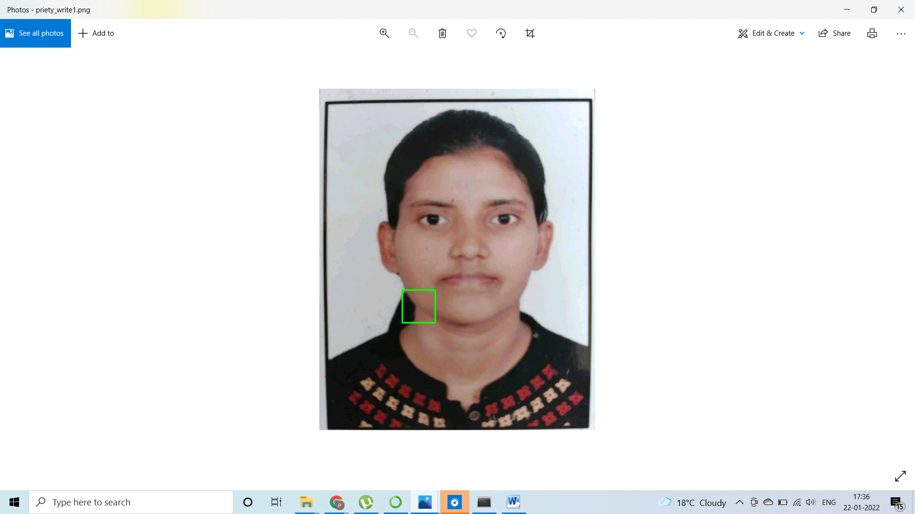

Again the face is not detected:still getting the same

img = cv.rectangle(img,(x1,y1),(x2,y2), (0,255,0),4)------🡪again not detected

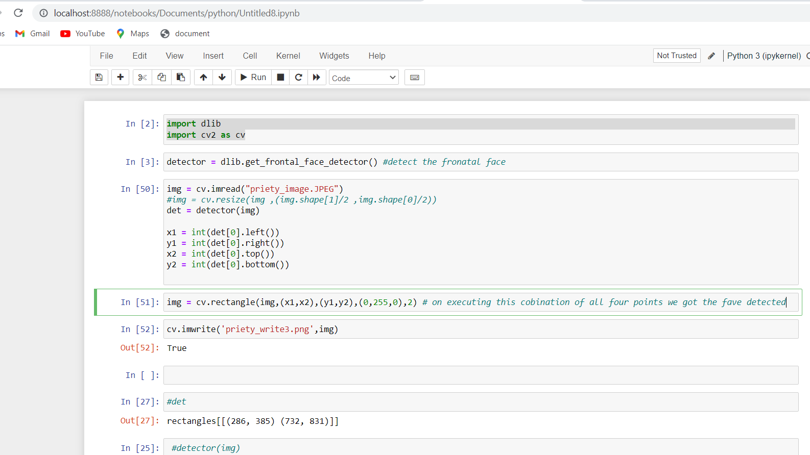

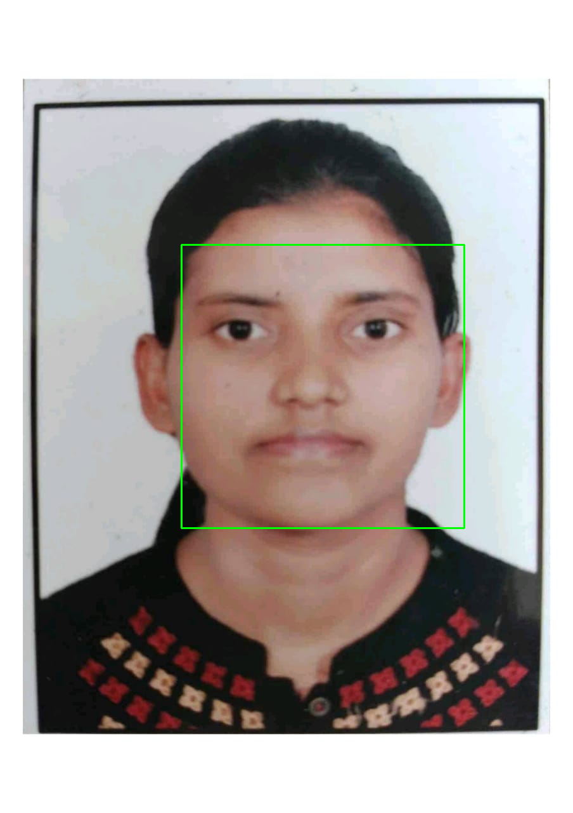

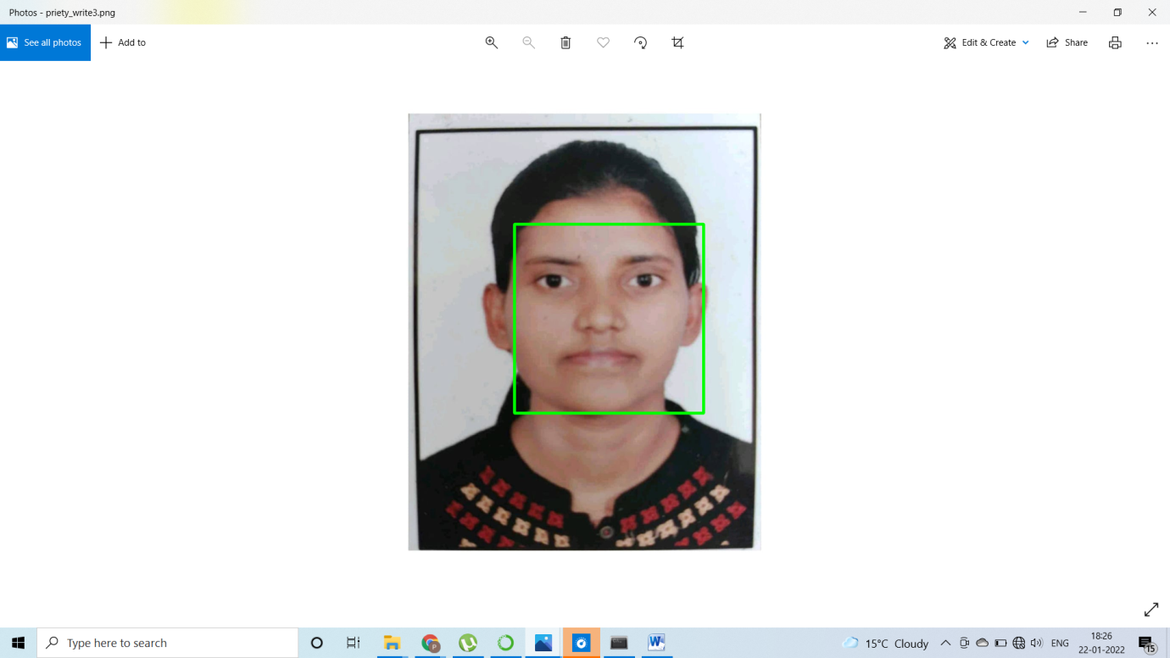

Now we are cropping the image. But we are not getting the face at center.

